**Q. 1 )**

**Given below is a dictionary having two keys ‘Boys’ and ‘Girls’ and having two lists of heights of five Boys and five Girls respectively as values associated with these keys.**

**Original dictionary of lists:**

**{'Boys': [72, 68, 70, 69, 74], 'Girls': [63, 65, 69, 62, 61]}**

**From the given dictionary of lists create the following list of dictionaries:**

**[{'Boys': 72, 'Girls': 63}, {'Boys': 68, 'Girls': 65}, {'Boys': 70, 'Girls': 69}, {'Boys': 69, 'Girls': 62}, {‘Boys’: 74, ‘Girls’: 61]**

**Code )**

|  |
| --- |
| d1 **=** {'Boys': [72, 68, 70, 69, 74], 'Girls': [63, 65, 69, 62, 61]} n **=** d1['Boys']**.**__len__()  list_d **=** [{k: a[i] **for** k, a **in** d1**.**items()} **for** i **in** range(n)]  print(f'''  \t\t\t Que. 1 Output \n Original Dictionary : {d1}\n  Derived List of dicts :  {list_d}  ''') |

In [1]:

Que. 1 Output

Original Dictionary :

{'Boys': [72, 68, 70, 69, 74], 'Girls': [63, 65, 69, 62, 61]}

Derived List of dicts :

[{'Boys': 72, 'Girls': 63}, {'Boys': 68, 'Girls': 65}, {'Boys': 70, 'Girls': 69},

{'Boys': 69, 'Girls': 62}, {'Boys': 74, 'Girls': 61}]

**Q. 2 )**

**Write programs in Python using NumPy library to do the following:**

1. **Compute the mean, standard deviation, and variance of a two dimensional randominteger array along the second axis.**
2. **Get the indices of the sorted elements of a given array.**

**B = [56, 48, 22, 41, 78, 91, 24, 46, 8, 33]**

1. **Create a 2-dimensional array of size m x n integer elements, also print the shape,type and data type of the array and then reshape it into n x m array, n and m are user inputs given at the run time.**
2. **Test whether the elements of a given array are zero, non-zero and NaN. Record theindices of these elements in three separate arrays.**

**Code )**

|  |
| --- |
| **import** numpy **as** np  *# a. Computing mean, sd, var along with axis 2* arr **=** np**.**random**.**randint(100, size**=**(2, 2)) print('\t\t\tQue 2 Output \n')  print(f'''-------------------------------------------------------------------- \nA.\n\nRandom 2D array of {arr**.**shape} diameter:\n{arr} \n  Array Stats regard axis 2 :  Mean \t\t\t: {arr**.**mean(1)}  Standard Deviation \t: {np**.**sqrt(arr**.**var(1))}  Variance \t\t: {arr**.**var(1)}  ''') |

In [1]:

Que 2 Output

-------------------------------------------------------------------- A.

Random 2D array of (2, 2) diameter:

[[ 7 78]

[36 56]]

Array Stats regard axis 2 :

Mean : [42.5 46. ]

Standard Deviation : [35.5 10. ]

Variance : [1260.25 100. ]

|  |
| --- |
| *# b. Sorting array's indices*  arr **=** np**.**array([56, 48, 22, 41, 78, 91, 24, 46, 8, 33]) index **=** arr**.**argsort() print(f'''--------------------------------------------------------------------  \nB.\n\nGiven Numpy Integer Array : {arr}  Indices of sorted elements : {index}  Access Array using indices : {arr[index[0::]]} ''') |

In [2]:

-------------------------------------------------------------------- B.

Given Numpy Integer Array : [56 48 22 41 78 91 24 46 8 33]

Indices of sorted elements : [8 2 6 9 3 7 1 0 4 5]

Access Array using indices : [ 8 22 24 33 41 46 48 56 78 91]

|  |
| --- |
| *# c. Simple Matrix Simulation*  print('--------------------------------------------------------------------') print('\nC.\n\nEnter the parameters of matrix :') m, n **=** [int(x) **for** x **in** input("rows & columns (use space) : ")**.**split()] arr **=** np**.**random**.**randint(10**\***m**\***n, size**=**(m, n)) print(f'''  Created Array : \n{arr}\n  Array Details :  Shape : {arr**.**shape}  Data Type : {arr**.**dtype}  Obj Type : {type(arr)} \n  Reshaped Array into {n} x {m}: \n{arr**.**reshape(n,m)} ''') |

In [3]:

-------------------------------------------------------------------- C.

Enter the parameters of matrix :

Created Array :

[[ 58 102 82 118]

[ 64 74 114 98]

[ 22 92 66 87]]

Array Details :

Shape : (3, 4)

Data Type : int32

Obj Type : <class 'numpy.ndarray'>

Reshaped Array into 4 x 3:

[[ 58 102 82]

[118 64 74]

[114 98 22]

[ 92 66 87]]

|  |
| --- |
| *# d. Checking that elements are zero, non-zero or null* **def** cmp_arr(arr: np**.**ndarray, cmp): **return** np**.**array([i **for** i **in** range(len(arr)) **if** cmp(arr[i])])  x **=** np**.**array([2, np**.**NaN, 0, 4, np**.**NaN, 5, 0, **-**7, np**.**NaN])  zero **=** cmp_arr(x, cmp**=lambda** a: a **==** 0) nzero **=** cmp_arr(x, cmp**=lambda** a: a **>** 0 **or** a **<** 0) nan **=** cmp_arr(x, cmp**=lambda** a: np**.**isnan(a))  print(f'''--------------------------------------------------------------------  \nD.\n\nGiven Array (x) : {x}  \nIndices of array x that are equal to :  Zero : {zero}  Non-Zero : {nzero}  NaN : {nan}  --------------------------------------------------------------------''') |

In [4]:

-------------------------------------------------------------------- D.

Given Array (x) : [ 2. nan 0. 4. nan 5. 0. -7. nan]

Indices of array x that are equal to :

Zero : [2 6]

Non-Zero : [0 3 5 7]

NaN : [1 4 8]

--------------------------------------------------------------------

**Q. 3 )**

**Create a dataframe having at least 3 columns and 50 rows to store numeric data generated using a random function. Replace 10% of the values by null values whose index positions are generated using random function.**

**Do the following:**

1. **Identify and count missing values in a dataframe.**
2. **Drop the column having more than 5 null values.**
3. **Identify the row label having maximum of the sum of all values in a row and dropthat row.**
4. **Sort the dataframe on the basis of the first column.**
5. **Remove all duplicates from the first column.**
6. **Find the correlation between first and second column and covariance betweensecond and third column.**
7. **Detect the outliers and remove the rows having outliers.**
8. **Discretize second column and create 5 bins.**

**Code )**

|  |
| --- |
| **import** pandas **as** pd **from** numpy **import** random  nrows **=** 50  *# creating a dataframe*  df **=** pd**.**DataFrame({'Age': random**.**randint(10, 90, nrows), 'Height': random**.**randint(150, 200, nrows),  'Weight': random**.**randint(50, 200, nrows), })  *# replacing 10% random values to null* ncols **=** len(df**.**columns) **while** df**.**isnull()**.**sum()**.**sum() **!=** (ncols **\*** nrows **//** 10): df**.**iloc[random**.**randint(nrows), random**.**randint(ncols)] **=** **None**  print(f'''\t\t\tQ.3 Output \n  --------------------------------------------------------------------  \nGiven DataFrame's head : \n {df**.**head()}\n\nDetails : \n''') df**.**info() |

In [4]:

Q.3 Output

-------------------------------------------------------------------- Given DataFrame's head :

Age Height Weight

1. 25.0 168.0 121.0
2. 53.0 177.0 112.0
3. 88.0 179.0 83.0
4. NaN 167.0 NaN
5. 83.0 159.0 76.0 Details :

<class 'pandas.core.frame.DataFrame'>

RangeIndex: 50 entries, 0 to 49 Data columns (total 3 columns):

# Column Non-Null Count Dtype

--- ------ -------------- -----

1. Age 45 non-null float64
2. Height 46 non-null float64 2 Weight 44 non-null float64 dtypes: float64(3) memory usage: 1.3 KB

|  |
| --- |
| *# A. Identifying & counting null values* var1 **=** df**.**isnull()**.**sum()  print(f'''\n--------------------------------------------------------------------  \nA.\n\nTotal null values in Given DataFrame : {sum(var1)}\n  {var1}  ''') |

In [5]:

-------------------------------------------------------------------- A.

Total null values in Given DataFrame : 15

Age 5

Height 4 Weight 6

dtype: int64

|  |
| --- |
| *# B. Dropping cols with more than 5 null* var1 **=** [i **for** i **in** df **if** var1[i] **>** 5]  print(f'''--------------------------------------------------------------------  \nB.\n\nColumns with more than 5 null values : {var1}\n  DataFrame after dropping columns : \n  {df**.**drop(columns**=**var1)**.**head()}  ''')  *# df.dropna(thresh = len(df) - 5, axis = 1)* |

In [12]:

-------------------------------------------------------------------- B.

Columns with more than 5 null values : ['Height'] DataFrame after dropping columns :

Age Weight

1. 55.0 127.0
2. 58.0 NaN
3. 86.0 141.0
4. 69.0 188.0
5. 49.0 138.0

|  |
| --- |
| *# C. Dropping row with max row_sum value* var1 **=** df**.**sum(axis**=**1)**.**idxmax()  print(f'''--------------------------------------------------------------------  \nC.\n\nRow with max sum value : {var1}\n  DataFrame after dropping row {var1} : \n  {df**.**drop(index**=**var1)[(var1 **-** 2) : (var1 **+** 2)]} ''') |

In [17]:

-------------------------------------------------------------------- C.

Row with max sum value : 37

DataFrame after dropping row 37 :

Age Height Weight

44 68.0 161.0 173.0

14 69.0 156.0 84.0

3 69.0 NaN 188.0

24 70.0 164.0 151.0

|  |
| --- |
| *# D. Sorting DataFrame according to 1st col* df **=** df**.**sort_values(by**=**df**.**columns[0])  print(f'''--------------------------------------------------------------------  \nD.\n\nSorted dataFarme on the basis of first column : \n  {df**.**head()}\n\n{df**.**shape}  ''') |

In [15]:

-------------------------------------------------------------------- D.

Sorted dataFarme on the basis of first column :

Age Height Weight

47 10.0 191.0 79.0

10 10.0 177.0 153.0

22 11.0 NaN 168.0

35 14.0 157.0 NaN

15 15.0 NaN 106.0

(50, 3)

|  |
| --- |
| *# E. Removing duplicates from the 1st col* df**.**drop_duplicates(df**.**columns[0], inplace**=True**)  print(f'''--------------------------------------------------------------------  \nE.\n\nDataFarme after removing duplicates from the first column : \n {df**.**head()}  \n{df**.**shape}''') |

In [19]:

-------------------------------------------------------------------- E.

DataFarme after removing duplicates from the first column :

Age Height Weight

47 10.0 191.0 79.0

22 11.0 NaN 168.0

35 14.0 157.0 NaN

15 15.0 NaN 106.0

8 16.0 159.0 170.0

(41, 3)

In [79]:

|  |
| --- |
| *# F. Calculating correlation & covariance* var1 **=** df**.**columns  print(f'''--------------------------------------------------------------------  \nF.\n\nCorrelation between first & second column : {df[var1[0]]**.**corr(df[var1[1]])  \nCovariance between second & third column : {df[var1[1]]**.**cov(df[var1[2]])} ''') |

}

-------------------------------------------------------------------- F.

Correlation between first & second column : -0.2497633957546939

Covariance between second & third column : 51.89818548387097

In [22]: *# G. Detect & remove the row having outliers*

q **=** df**.**quantile(q**=**[0.25, 0.75])

q**.**loc['IQR'] **=** q**.**iloc[1] **-** q**.**iloc[0]

|  |
| --- |
| q**.**loc['low'] **=** q**.**iloc[0] **-** 1.5 **\*** q**.**iloc[2]  q**.**loc['high'] **=** q**.**iloc[1] **+** 1.5 **\*** q**.**iloc[2] df **=** df[**~**((df **<** (q**.**loc['low'])) **|** (df **>** (q**.**loc['high'])))**.**any(axis**=**1)]  print(f'''--------------------------------------------------------------------  \nG.\n\nInter-Quartile Parameters for the outliers : \n\n{q}  \nDataFrame after removing outliers : \n\n{df**.**head()}\n\n{df**.**shape} ''') |

-------------------------------------------------------------------- G.

Inter-Quartile Parameters for the outliers :

Age Height Weight

0.25 28.75 158.0 82.75 0.75 67.25 184.0 169.25 IQR 38.50 26.0 86.50 low -29.00 119.0 -47.00 high 125.00 223.0 299.00

DataFrame after removing outliers :

Age Height Weight

47 10.0 191.0 79.0

22 11.0 NaN 168.0

35 14.0 157.0 NaN

15 15.0 NaN 106.0

8 16.0 159.0 170.0

(41, 3)

In [87]: *# H. Discretizing second column & creating 5 bins*

df['binned'] **=** pd**.**qcut(df[df**.**columns[1]], q**=**5) var1 **=** df**.**binned**.**unique() print(f'''------------------------------------------------------------------------\nH.\n

Bins created for second column : \n

{var1**.**categories**.**values}

\nDataFrame after discretizing & creating 5 bins for second column : \n

{df**.**head()}\n\n{df**.**shape}

--------------------------------------------------------------------------------------------------------------------------------------------------------------------

------------ H.

Bins created for second column :

<IntervalArray>

[(149.999, 157.0], (157.0, 161.0], (161.0, 177.4], (177.4, 185.8], (185.8, 199.0]]

Length: 5, dtype: interval[float64, right]

DataFrame after discretizing & creating 5 bins for second column :

Age Height Weight binned

47 10.0 191.0 79.0 (185.8, 199.0]

22 11.0 NaN 168.0 NaN

35 14.0 157.0 NaN (149.999, 157.0]

15 15.0 NaN 106.0 NaN

8 16.0 159.0 170.0 (157.0, 161.0]

(41, 4)

----------------------------------------------------------------------------------

------------

**Q.4. )**

**Consider two excel files having attendance of a workshop’s participants for two days. Each file has three fields ‘Name’, ‘Time of joining’, duration (in minutes) where names are unique within a file.**

**Note that duration may take one of three values (30, 40, 50) only.**

**Import the data into two dataframes and do the following:**

1. **Perform merging of the two dataframes to find the names of students who hadattended the workshop on both days.**
2. **Find names of all students who have attended workshop on either of the days.**
3. **Merge two data frames row-wise and find the total number of records in the dataframe.**
4. **Merge two data frames and use two columns names and duration as multi-rowindexes. Generate descriptive statistics for this multi-index.**

**Code )**

|  |
| --- |
| **import** pandas **as** pd  df1 **=** pd**.**read_excel('Day1.xlsx') df2 **=** pd**.**read_excel('Day2.xlsx')  print(f'''  \t\t\t Q.4 Output  -------------------------------------------------------------------- |

In [4]:

Day1 excel file : \n

{df1**.**head()}

\n{df1**.**shape}

--------------------------------------------------------------------

Day2 excel file : \n

{df2**.**head()}

\n{df2**.**shape} ''')

Q.4 Output

-------------------------------------------------------------------- Day1 excel file :

Name Time of Joining Duration

1. Abhimanyu 11:00:00 40
2. Abhishek 11:04:00 30
3. Aasif 11:08:00 30
4. Aman 11:01:00 40
5. Anand 11:12:00 50

(15, 3)

-------------------------------------------------------------------- Day2 excel file :

Name Time of Joining Duration

1. Abhimanyu 11:00:00 40
2. Abhishek 11:06:00 30
3. Deepanshu 11:10:00 40
4. Aman 11:09:00 40
5. Anubhav 11:10:00 50

(15, 3)

|  |
| --- |
| *# A. Merge two dataframes & find the names of students*  *# who had attended the workshop on both days*  mdf **=** pd**.**merge(df1, df2, how **=** 'inner', on **=** 'Name') print(f'''  ----------------------------------------------------------------------------  \nA.\n  Merged DataFrame :\n  {mdf**.**head()} \n {mdf**.**shape}  Name of the students who attended workshop on both days :\n  {mdf**.**Name}  ''') |

In [5]:

Merged DataFrame :

1. Abhimanyu 11:00:00 40 11:00:00 40
2. Abhishek 11:04:00 30 11:06:00 30
3. Aman 11:01:00 40 11:09:00 40
4. Anubhav 11:10:00 30 11:10:00 50
5. Anurag 11:11:00 30 11:08:00 30

(10, 5)

Name of the students who attended workshop on both days :

1. Abhimanyu
2. Abhishek
3. Aman
4. Anubhav
5. Anurag
6. Arpit
7. Bhavana
8. Deepanshu
9. Ishant
10. Harshit

Name: Name, dtype: object

|  |
| --- |
| *# B. Find the names of students who had attended the workshop on either of days*  mdf1 **=** pd**.**merge(df1, df2, how **=** 'outer', on **=** 'Name') print(f'''  ----------------------------------------------------------------------------  \nB.\n  Merged DataFrame :\n  {mdf1**.**head()} \n  {mdf1**.**shape}  Name of the students who attended workshop on either of days :\n  {mdf1**.**Name}  ''') |

In [6]:

Merged DataFrame :

1. Abhimanyu 11:00:00 40.0 11:00:00 40.0
2. Abhishek 11:04:00 30.0 11:06:00 30.0
3. Aasif 11:08:00 30.0 NaN NaN
4. Aman 11:01:00 40.0 11:09:00 40.0
5. Anand 11:12:00 50.0 NaN NaN

(20, 5)

Name of the students who attended workshop on either of days :

1. Abhimanyu
2. Abhishek
3. Aasif
4. Aman
5. Anand
6. Anubhav
7. Anurag
8. Arpit
9. Akanksha
10. Bhavana
11. Deepanshu
12. Ishant
13. Gourav
14. Harshit
15. Kartikey
16. Bharat
17. Divyanshu
18. Deepak
19. Jayesh
20. Jeeva

Name: Name, dtype: object

|  |
| --- |
| *# C. Merge the DataFrame row-wise & find the total no. of records*  print(f'''  ---------------------------------------------------------------------------- \nC.\n  Row-wise Merged DataFrame :\n  {mdf1**.**head()} \n {mdf1**.**shape}  Total no. of records : {len(mdf1)} ''') |

In [7]:

Row-wise Merged DataFrame :

1. Abhimanyu 11:00:00 40.0 11:00:00 40.0
2. Abhishek 11:04:00 30.0 11:06:00 30.0
3. Aasif 11:08:00 30.0 NaN NaN
4. Aman 11:01:00 40.0 11:09:00 40.0
5. Anand 11:12:00 50.0 NaN NaN

(20, 5)

Total no. of records : 20

|  |
| --- |
| *# D. Merge the DataFrame with two columns Name & Duration as indices*  *# Generate Descriptive Statistics*  mdf2 **=** pd**.**merge(df1, df2, how **=** 'outer', on **=** ['Name', 'Duration']) mdf2**.**set_index(['Name', 'Duration'], inplace **=** **True**)  cols **=** mdf2**.**columns mdf2[cols[0]] **=** pd**.**to_datetime(mdf2[cols[0]], format**=**'%H:%M:%S')**.**dt**.**time mdf2[cols[1]] **=** pd**.**to_datetime(mdf2[cols[1]], format**=**'%H:%M:%S')**.**dt**.**time desc **=** mdf2**.**describe()  t1 **=** mdf2[cols[0]] t2 **=** mdf2[cols[1]] t1**.**dropna(inplace **=** **True**) t2**.**dropna(inplace **=** **True**)  desc**.**loc['min'] **=** [t1**.**min(), t2**.**min()] desc**.**loc['max'] **=** [t1**.**max(), t2**.**max()]  print(f'''  ----------------------------------------------------------------------------  \nD.\n  Merged DataFrame :\n  {mdf2**.**head()} \n {mdf2**.**shape}  Descriptive Statistics :\n\n {desc}  ----------------------------------------------------------------------------''') |

In [10]:

Merged DataFrame :

Time of Joining_x Time of Joining_y

Name Duration

Abhimanyu 40 11:00:00 11:00:00

Abhishek 30 11:04:00 11:06:00

Aasif 30 11:08:00 NaT

Aman 40 11:01:00 11:09:00

Anand 50 11:12:00 NaT

(21, 2)

Descriptive Statistics :

Time of Joining_x Time of Joining_y count 15 15 unique 14 9 top 11:08:00 11:08:00 freq 2 3 min 11:00:00 11:00:00 max 11:19:00 11:14:00

----------------------------------------------------------------------------

**Q.5 )**

**Taking Iris data, plot the following with proper legend and axis labels:**

**(Download IRIS data from:** [**https://archive.ics.uci.edu/ml/datasets/iris**](https://archive.ics.uci.edu/ml/datasets/iris) **or import it from sklearn.datasets)**

1. **Plot bar chart to show the frequency of each class label in the data.**
2. **Draw a scatter plot for Petal width vs sepal width.**
3. **Plot density distribution for feature petal length.**
4. **Use a pair plot to show pairwise bivariate distribution in the Iris Dataset.**

**Code )**

|  |
| --- |
| **from** sklearn **import** datasets **import** pandas **as** pd **import** matplotlib.pyplot **as** plt **import** seaborn **as** sns  *# iris dataset*  df **=** datasets**.**load_iris() iris **=** pd**.**DataFrame(data **=** df**.**data, columns **=** df**.**feature_names) t_names **=** {0:df**.**target_names[0], 1: df**.**target_names[1], 2: df**.**target_names[2]} iris['type'] **=** df**.**target iris['type'] **=** iris['type']**.**map(t_names) color **=** ['r','g','b','y'] |

In [39]:

|  |
| --- |
| print(f'''  \t\t\t\t Q.5 Output  -----------------------------------------------------------------------------------  \nIris Dataset : \n  {iris**.**head()} \n  {iris**.**shape}  \nDetails :  ''') iris**.**info() |

Q.5 Output

----------------------------------------------------------------------------------

-

Iris Dataset :

sepal length (cm) sepal width (cm) petal length (cm) petal width (cm) \ 0 5.1 3.5 1.4 0.2

1. 4.9 3.0 1.4 0.2
2. 4.7 3.2 1.3 0.2
3. 4.6 3.1 1.5 0.2 4 5.0 3.6 1.4 0.2

type 0 setosa

1. setosa
2. setosa
3. setosa
4. setosa

(150, 5)

Details :

<class 'pandas.core.frame.DataFrame'> RangeIndex: 150 entries, 0 to 149

Data columns (total 5 columns):

# Column Non-Null Count Dtype

--- ------ -------------- -----

1. sepal length (cm) 150 non-null float64
2. sepal width (cm) 150 non-null float64
3. petal length (cm) 150 non-null float64
4. petal width (cm) 150 non-null float64 4 type 150 non-null object dtypes: float64(4), object(1) memory usage: 6.0+ KB

|  |
| --- |
| *# A. Bar Chart*  fig, ax **=** plt**.**subplots(2,2) fig**.**set_figwidth(16) fig**.**set_figheight(16)  **for** i **in** range(len(ax)): **for** j **in** range(len(ax[0])):  iris**.**iloc[:,i**+**1**^**j]**.**value_counts()**.**sort_index()**.**plot( kind **=** 'bar', ax **=** ax[i, j], color **=** color[i**+**1**^**j]) ax[i,j]**.**legend(fontsize **=** 13) ax[i,j]**.**grid(alpha **=** 0.5, linestyle **=** '-.') |

In [13]:

fig**.**suptitle('A. Bar Chart', fontweight **=** 'bold', fontsize **=** 25) fig**.**tight_layout() fig**.**subplots_adjust(top **=** 0.9)

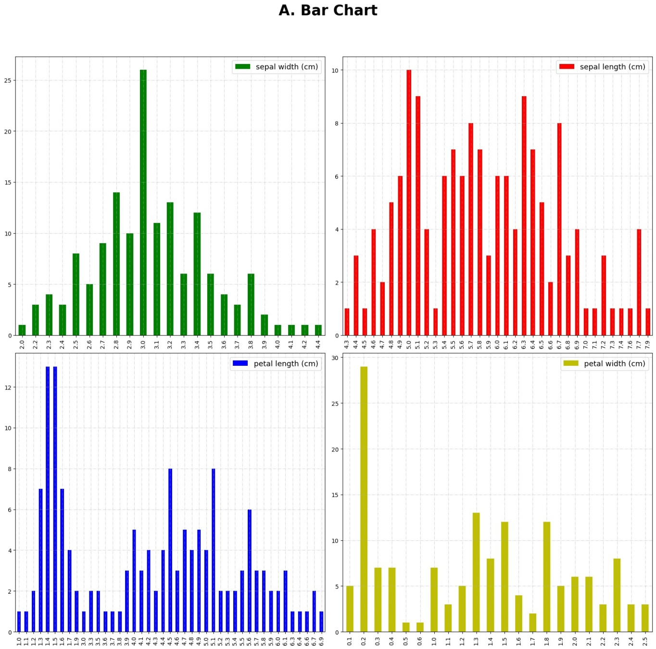

|  |
| --- |
| *# B. Scatter Plot*  sc **=** sns**.**lmplot(x **=** 'petal width (cm)', y **=** 'sepal width (cm)' , data**=**iris, fit_reg sc**.**fig**.**suptitle('B. Scatter Plot', fontsize **=** 18, fontweight **=** 'bold') sc**.**ax**.**legend(loc **=** 'upper right',fontsize **=** 14) sc**.**ax**.**set_xlabel('Petal Width',fontsize **=** 14) sc**.**ax**.**set_ylabel('Sepal Width',fontsize **=** 14) sc**.**ax**.**grid(linestyle **=** '--', alpha **=** 0.6) sc**.**tight_layout() plt**.**show() |

In [42]:

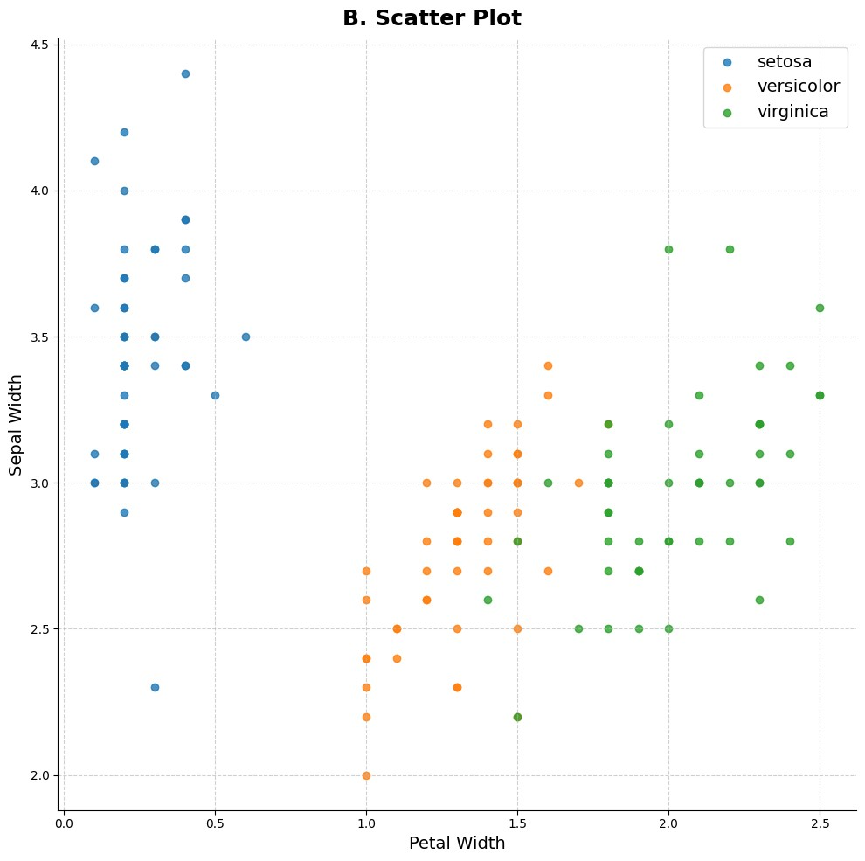

In [119…

|  |
| --- |
| *# C. Density Plot*  den **=** iris['petal length (cm)']**.**plot(kind **=** 'density', figsize **=** (9,9), linewidth den**.**legend(fontsize **=** 14) den**.**set_ylabel('Density', fontsize **=** 16) den**.**set_title('C. Density Distribution', fontsize **=** 18, fontweight **=** 'bold') |

**=**

Out[119]: Text(0.5, 1.0, 'C. Density Distribution')

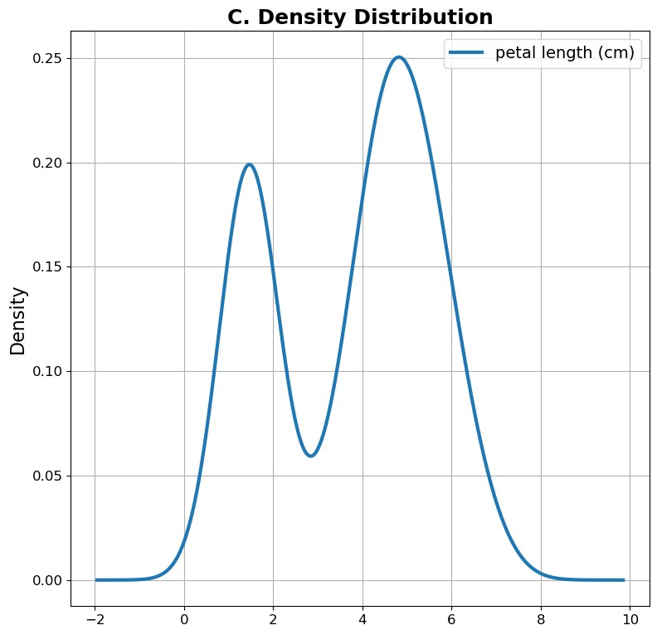

|  |
| --- |
| *# D. Pair Plot*  pair **=** sns**.**pairplot(iris, hue **=** 'type') pair**.**fig**.**suptitle('D. Pair-Plot', fontsize **=** 18, fontweight **=** 'bold') pair**.**tight_layout() plt**.**show() |

In [43]:

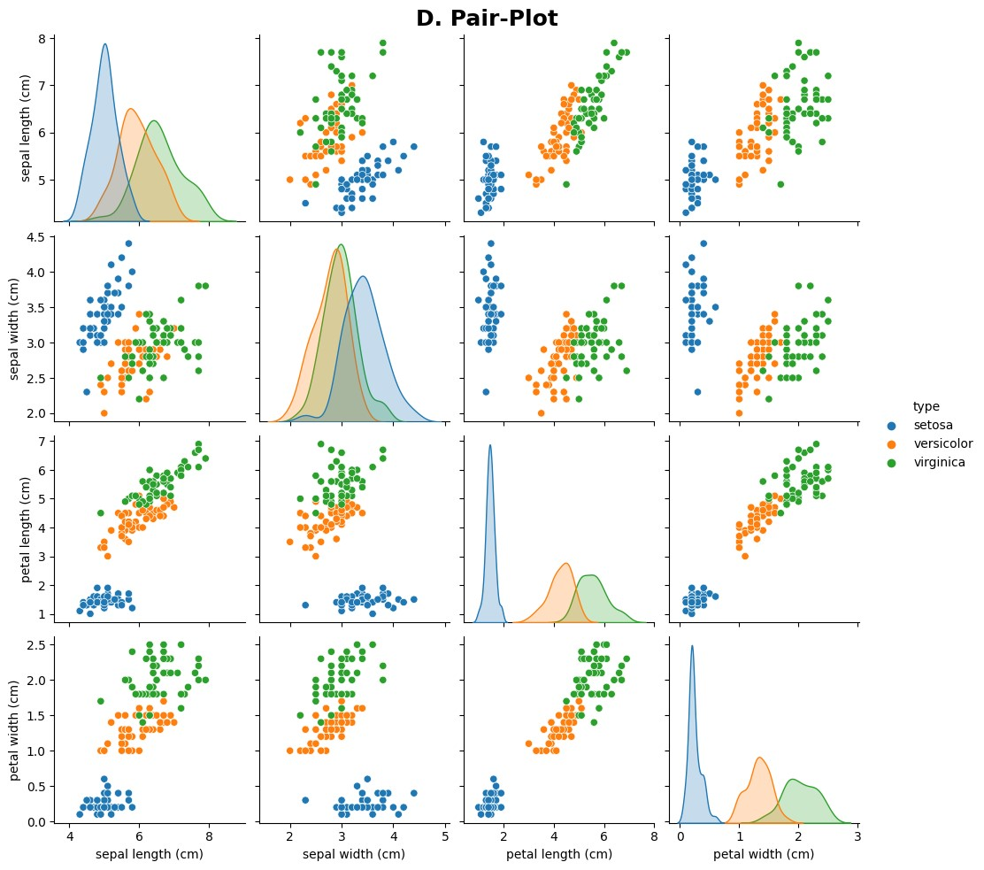

**Q.6 )**

**Consider any sales training/ weather forecasting dataset :**

1. **Compute mean of a series grouped by another series.**
2. **Fill an intermittent time series to replace all missing dates with values of previousnon-missing date.**
3. **Perform appropriate year-month string to dates conversion.**
4. **Split a dataset to group by two columns and then sort the aggregated results withinthe groups.**
5. **Split a given dataframe into groups with bin counts.**

**Code )**

|  |
| --- |
| **import** pandas **as** pd df **=** pd**.**read_csv('weather.csv')  print(f''' \t\t\t Q.6 Output |

In [114…

|  |
| --- |
| --------------------------------------------------------------------  Data file : \n  {df**.**head()}  \n{df**.**shape} \n  Details : ''') df**.**info() |

Q.6 Output

-------------------------------------------------------------------- Data file :

date temp_min temp_max wind_speed humidity weather 0 31/10/2020 17 29 7 40 sunny

1. 1/11/2020 18 30 8 39 sunny
2. NaN 19 30 9 49 sunny
3. 3/11/2020 17 28 13 59 sunny
4. 4/11/2020 20 29 18 89 cloudy

(22, 6)

Details :

<class 'pandas.core.frame.DataFrame'>

RangeIndex: 22 entries, 0 to 21 Data columns (total 6 columns):

# Column Non-Null Count Dtype

--- ------ -------------- -----

1. date 14 non-null object
2. temp_min 22 non-null int64
3. temp_max 22 non-null int64
4. wind_speed 22 non-null int64
5. humidity 22 non-null int64 5 weather 22 non-null object dtypes: int64(4), object(2) memory usage: 1.2+ KB

|  |
| --- |
| print(f'''  -------------------------------------------------------------------- \n A.\n  Mean of the other series based on weather type : \n  {df**.**groupby(['weather'])**.**mean(numeric_only **=** **True**)} ''') |

In [95]:

-------------------------------------------------------------------- A.

Mean of the other series based on weather type :

temp_min temp_max wind_speed humidity weather cloudy 21.000000 30.000000 10.666667 79.333333 cold 18.000000 25.600000 12.200000 43.000000 sunny 17.833333 29.166667 9.833333 49.166667

In [115… print(f'''

-------------------------------------------------------------------- \n B.\n

|  |
| --- |
| Total Null values in Date column : {df**.**date**.**isnull()**.**sum()}\n  DataFrame before changing : \n  {df**.**head(10)}  Changing null Dates with previous non-null dates :  ''')  df**.**fillna(method **=** 'ffill', inplace**=True**) df**.**head(10) |

-------------------------------------------------------------------- B.

Total Null values in Date column : 8 DataFrame before changing :

date temp_min temp_max wind_speed humidity weather 0 31/10/2020 17 29 7 40 sunny

1. 1/11/2020 18 30 8 39 sunny
2. NaN 19 30 9 49 sunny
3. 3/11/2020 17 28 13 59 sunny
4. 4/11/2020 20 29 18 89 cloudy
5. NaN 20 30 8 69 cloudy
6. 5/11/2020 23 31 6 80 cloudy
7. 6/11/2020 20 28 10 35 cold
8. NaN 18 25 14 37 cold
9. 8/11/2020 16 24 12 59 cold Changing null Dates with previous non-null dates :

Out[115]: **date temp_min temp_max wind_speed humidity weather**

**0** 31/10/2020 17 29 7 40 sunny

|  |  |  |  |  |  |  |
| --- | --- | --- | --- | --- | --- | --- |
| **1** | 1/11/2020 | 18 | 30 | 8 | 39 | sunny |
| **2** | 1/11/2020 | 19 | 30 | 9 | 49 | sunny |
| **3** | 3/11/2020 | 17 | 28 | 13 | 59 | sunny |
| **4** | 4/11/2020 | 20 | 29 | 18 | 89 | cloudy |
| **5** | 4/11/2020 | 20 | 30 | 8 | 69 | cloudy |
| **6** | 5/11/2020 | 23 | 31 | 6 | 80 | cloudy |
| **7** | 6/11/2020 | 20 | 28 | 10 | 35 | cold |
| **8** | 6/11/2020 | 18 | 25 | 14 | 37 | cold |
| **9** | 8/11/2020 | 16 | 24 | 12 | 59 | cold |

|  |
| --- |
| print(f'''  -------------------------------------------------------------------- \n C.\n  DataFrame before changing :  ''') df**.**info() df**.**date **=** pd**.**to_datetime(df**.**date, dayfirst**=True**) print('\n\nDataframe after converting string to dates :\n') df**.**info() |

In [121…

-------------------------------------------------------------------- C.

DataFrame before changing :

<class 'pandas.core.frame.DataFrame'>

RangeIndex: 22 entries, 0 to 21 Data columns (total 6 columns):

# Column Non-Null Count Dtype

--- ------ -------------- -----

1. date 22 non-null datetime64[ns]
2. temp_min 22 non-null int64
3. temp_max 22 non-null int64
4. wind_speed 22 non-null int64
5. humidity 22 non-null int64 5 weather 22 non-null object dtypes: datetime64[ns](1), int64(4), object(1) memory usage: 1.2+ KB

Dataframe after converting string to dates :

<class 'pandas.core.frame.DataFrame'>

RangeIndex: 22 entries, 0 to 21 Data columns (total 6 columns):

# Column Non-Null Count Dtype

--- ------ -------------- -----

1. date 22 non-null datetime64[ns]
2. temp_min 22 non-null int64
3. temp_max 22 non-null int64
4. wind_speed 22 non-null int64
5. humidity 22 non-null int64 5 weather 22 non-null object dtypes: datetime64[ns](1), int64(4), object(1) memory usage: 1.2+ KB

|  |
| --- |
| *# d. Split a dataset to group by two columns and*  *# sort the aggregated results within the groups.*  df1 **=** df**.**groupby(["date", "weather"])**.**agg(**lambda** x: x**.**sort_values()**.**head(3)) print(f'''  -------------------------------------------------------------------- \n D.\n  DataFrame grouped by weather & dates :\n  {df1}  ''') |

In [126…

-------------------------------------------------------------------- D.

DataFrame grouped by weather & dates :

temp_min temp_max wind_speed humidity date weather 2020-10-31 sunny 17 29 7 40

2020-11-01 sunny [18, 19] [30, 30] [8, 9] [39, 49]

2020-11-03 sunny 17 28 13 59

2020-11-04 cloudy [20, 20] [29, 30] [8, 18] [69, 89]

2020-11-05 cloudy 23 31 6 80

2020-11-06 cold [18, 20] [25, 28] [10, 14] [35, 37] 2020-11-08 cold 16 24 12 59 sunny 19 30 9 49 2020-11-09 sunny 17 28 13 59

2020-11-10 cold [18, 20] [25, 28] [10, 14] [35, 37]

2020-11-12 cold [16, 18] [24, 25] [12, 14] [37, 59]

2020-11-14 cloudy [20, 20] [29, 30] [8, 18] [69, 89]

2020-11-15 cloudy 23 31 6 80

2020-11-16 cold [18, 20] [25, 28] [10, 14] [35, 37]

2020-11-18 cold 16 24 12 59

In [133… print(f'''

--------------------------------------------------------------------

\n E.\n

DataFrame grouped by bin_counts :\n

{df**.**groupby(['wind_speed', pd**.**cut(df**.**humidity, 3)])**.**size()**.**unstack()} ''')

-------------------------------------------------------------------- E.

DataFrame grouped by bin_counts :

humidity (34.946, 53.0] (53.0, 71.0] (71.0, 89.0] wind_speed 6 0 0 2

1. 1 0 [1]
2. 1 2 0
3. 2 0 0
4. 3 0 0
5. 0 3 0
6. 0 2 0
7. 4 0 0

18 0 0 2

**Q. 7 )**

**Consider a data frame containing data about students i.e. name, gender and passing division:**

**S.N. Name Birth_Month Gender Pass_Division**

**S.N. Name Birth_Month Gender Pass_Division**

|  |  |  |  |  |
| --- | --- | --- | --- | --- |
| **1** | **Seema Chopra** | **January** | **F** | **II** |
| **2** | **Rani Gupta** | **March** | **F** | **I** |
| **3** | **Aditya Narayan** | **October** | **M** | **I** |
| **4** | **Sanjeev Sahni** | **February** | **M** | **II** |
| **5** | **Prakash Kumar** | **December** | **M** | **III** |
| **6** | **Ritu Agarwal** | **September** | **F** | **I** |
| **7** | **Akshay Goel** | **August** | **M** | **I** |
| **8** | **Meeta Kulkarni** | **July** | **F** | **II** |
| **9** | **Preeti Ahuja** | **November** | **F** | **II** |
| **10** | **Sunil Das Gupta** | **April** | **M** | **III** |
| **11** | **Sonali Sapre** | **January** | **F** | **I** |
| **12** | **Rashmi Talwar** | **June** | **F** | **III** |
| **13** | **Ashish Dubey** | **May** | **M** | **II** |
| **14** | **Kiran Sharma** | **February** | **F** | **II** |
| **15** | **Sameer Bansal** | **October** | **M** | **I** |

1. **Perform one hot encoding of the last two columns of categorical data using theget_dummies() function.**
2. **Sort this data frame on the “Birth Month” column (i.e. January to December). Hint:**

**Convert Month to Categorical.**

**Code )**

In [9]:

|  |
| --- |
| **import** pandas **as** pd **import** numpy **as** np  bm **=** np**.**array(['January', 'February', 'March', 'April', 'May', 'June',  'July', 'August', 'September', 'October', 'November', 'December'])  gen **=** np**.**array(['M', 'F']) p_div **=** np**.**array(['I', 'II', 'III'])  df **=** pd**.**DataFrame({  'Name' : ['Mudit Chauhan', 'Seema Chopra', 'Rani Gupta', 'Aditya Narayan',  'Sanjeev Sahni', 'Prakash Kumar', 'Ritu Agarwal', 'Akshay Goel',  'Meeta Kulkarni', 'Preeti Ahuja', 'Sunil Das Gupta', 'Sonali Sapre  'Rashmi Talwar', 'Ashish Dubey', 'Kiran Sharma', 'Sameer Bansal'  'Birth_Month': bm[[11,0,2,9,1,11,8,7,6,10,3,0,5,4,1,9]],  'Gender' : gen[[0,1,1,0,0,0,1,0,1,1,0,1,1,0,1,0]],  'Pass_Division' : p_div[[2,1,0,0,1,2,0,0,1,1,2,0,2,1,1,0]]  })  print(f'''\t\t\t Q.7 Output  \n-------------------------------------------------------------------------\n Given DataFrame : \n\n{df}''') |

,]

Q.7 Output

------------------------------------------------------------------------- Given DataFrame :

Name Birth_Month Gender Pass_Division

1. Mudit Chauhan December M III
2. Seema Chopra January F II
3. Rani Gupta March F I
4. Aditya Narayan October M I
5. Sanjeev Sahni February M II
6. Prakash Kumar December M III
7. Ritu Agarwal September F I
8. Akshay Goel August M I
9. Meeta Kulkarni July F II
10. Preeti Ahuja November F II
11. Sunil Das Gupta April M III
12. Sonali Sapre January F I
13. Rashmi Talwar June F III
14. Ashish Dubey May M II
15. Kiran Sharma February F II
16. Sameer Bansal October M I

|  |
| --- |
| print(f'''  \n-------------------------------------------------------------------------\n A. \n  Performing one hot encoding on the last two columns : \n  {pd**.**get_dummies(df, columns**=**['Gender', 'Pass_Division'])} ''') |

In [11]:

------------------------------------------------------------------------- A.

Performing one hot encoding on the last two columns :

Name Birth_Month Gender_F Gender_M Pass_Division_I \

1. Mudit Chauhan December 0 1 0
2. Seema Chopra January 1 0 0
3. Rani Gupta March 1 0 1
4. Aditya Narayan October 0 1 1
5. Sanjeev Sahni February 0 1 0
6. Prakash Kumar December 0 1 0
7. Ritu Agarwal September 1 0 1
8. Akshay Goel August 0 1 1
9. Meeta Kulkarni July 1 0 0
10. Preeti Ahuja November 1 0 0
11. Sunil Das Gupta April 0 1 0
12. Sonali Sapre January 1 0 1
13. Rashmi Talwar June 1 0 0
14. Ashish Dubey May 0 1 0
15. Kiran Sharma February 1 0 0
16. Sameer Bansal October 0 1 1

Pass_Division_II Pass_Division_III

1. 0 1
2. 1 0
3. 0 0
4. 0 0
5. 1 0
6. 0 1
7. 0 0
8. 0 0
9. 1 0
10. 1 0
11. 0 1
12. 0 0
13. 0 1
14. 1 0
15. 1 0
16. 0 0

In [3]: df['Birth_Month'] **=** pd**.**Categorical(df['Birth_Month'], categories**=**bm) print(f'''------------------------------------------------------------------------B. \n

Sorting DataFrame by the Birth_Month : \n

{df**.**sort_values(by **=** 'Birth_Month')}

\n-------------------------------------------------------------------------

''')

------------------------------------------------------------------------- B.

Sorting DataFrame by the Birth_Month :

Name Birth_Month Gender Pass_Division

1 Seema Chopra January F II

11 Sonali Sapre January F I

4 Sanjeev Sahni February M II

14 Kiran Sharma February F II

2 Rani Gupta March F I

10 Sunil Das Gupta April M III

13 Ashish Dubey May M II

12 Rashmi Talwar June F III

8 Meeta Kulkarni July F II

7 Akshay Goel August M I

6 Ritu Agarwal September F I

3 Aditya Narayan October M I

15 Sameer Bansal October M I

9 Preeti Ahuja November F II

0 Mudit Chauhan December M III

5 Prakash Kumar December M III -------------------------------------------------------------------------

**Q. 8 )**

**Consider the following data frame containing a family name, gender of the family member and her/his monthly income in each record.**

**Name Gender MonthlyIncome(Rs.)**

**Shah Male 114000.00**

|  |  |  |
| --- | --- | --- |
| **Vats** | **Male** | **65000.00** |
| **Vats** | **Female** | **43150.00** |
| **Kumar** | **Female** | **69500.00** |
| **Vats** | **Female** | **155000.00** |
| **Kumar** | **Male** | **103000.00** |
| **Shah** | **Male** | **55000.00** |
| **Shah** | **Female** | **112400.00** |
| **Kumar** | **Female** | **81030.00** |
| **Vats** | **Male** | **71900.00** |

**Write a program in Python using Pandas to perform the following:**

1. **Calculate and display familywise gross monthly income.**
2. **Calculate and display the member with the highest monthly income in a family.**
3. **Calculate and display monthly income of all members with income greater than Rs.**

**60000.00.**

1. **Calculate and display the average monthly income of the female members in theShah family.**

**Code )**

|  |
| --- |
| **import** pandas **as** pd **import** numpy **as** np  name **=** np**.**array(['Shah', 'Vats', 'Kumar']) gender **=** np**.**array(['Male', 'Female'])  f_inc **=** pd**.**DataFrame({  'Name' : name[[0,1,1,2,1,2,0,0,2,1]],  'Gender' : gender[[0,0,1,1,1,0,0,1,1,0]],  'MonthlyIncome' : [114000, 65000, 43150, 69500, 155000, 103000, 55000, 112400,  })  print(f'''\t\t\t Q.8 Output  \n-------------------------------------------------------------------------\n Given DataFrame : \n\n{f_inc}  \n-------------------------------------------------------------------------\n A. \n  Calculating Familywise Gross Monthly Income : \n  {f_inc**.**groupby(by **=** 'Name')['MonthlyIncome']**.**sum()} ''') |

In [7]:

Q.8 Output

------------------------------------------------------------------------- Given DataFrame :

Name Gender MonthlyIncome

* + 1. Shah Male 114000
    2. Vats Male 65000
    3. Vats Female 43150
    4. Kumar Female 69500
    5. Vats Female 155000
    6. Kumar Male 103000
    7. Shah Male 55000
    8. Shah Female 112400
    9. Kumar Female 81030
    10. Vats Male 71900

------------------------------------------------------------------------- A.

Calculating Familywise Gross Monthly Income :

Name

Kumar 253530

Shah 281400

Vats 335050

Name: MonthlyIncome, dtype: int64

In [8]: print(f'''

\n-------------------------------------------------------------------------\n B. \n

Calculating Familywise Highesh Monthly Income : \n

{f_inc**.**groupby(by **=** ['Name', 'Gender'])['MonthlyIncome']**.**max()}

\n-------------------------------------------------------------------------\n C. \n

Calculating Members\' Monthly Income > 60000 : \n

{f_inc[f_inc**.**MonthlyIncome **>** 60000]}

\n-------------------------------------------------------------------------\n D. \n

Calculating average salary of female Shah member : \n

{f_inc[(f_inc**.**Name **==** 'Shah') **&** (f_inc**.**Gender **==** 'Female')]['MonthlyIncome']**.**mean()

\n-------------------------------------------------------------------------\n ''') ------------------------------------------------------------------------- B.

Calculating Familywise Highesh Monthly Income :

Name Gender

Kumar Female 81030

Male 103000

Shah Female 112400

Male 114000

Vats Female 155000

Male 71900

Name: MonthlyIncome, dtype: int64 ------------------------------------------------------------------------- C.

Calculating Members' Monthly Income > 60000 :

Name Gender MonthlyIncome

1. Shah Male 114000
2. Vats Male 65000
3. Kumar Female 69500
4. Vats Female 155000
5. Kumar Male 103000
6. Shah Female 112400
7. Kumar Female 81030
8. Vats Male 71900

------------------------------------------------------------------------- D.

Calculating average salary of female Shah member :

112400.0 Rs.

-------------------------------------------------------------------------

1. Mudit Chauhan December M III